DK000141
Task No. | DK000141
Test Case ID | TC_1
Test Case  Type | Functionality
Test Browser | Chrome
Test Steps | - Login to the Dharmakarma portal i.e. https://dharmakarma.net/  - Enter email and password  - Click on sign in button.  - After login Check Submit button, All FO WFM button, Magnify button in WFM table page
Test data | My WFM, Submit button, Magnify button, All FO WFM button.
Expected Result | Check Submit button, All FO WFM button, Magnify button in WFM Table buttons are responsive for smaller devices.
Actual Result  In WFM | 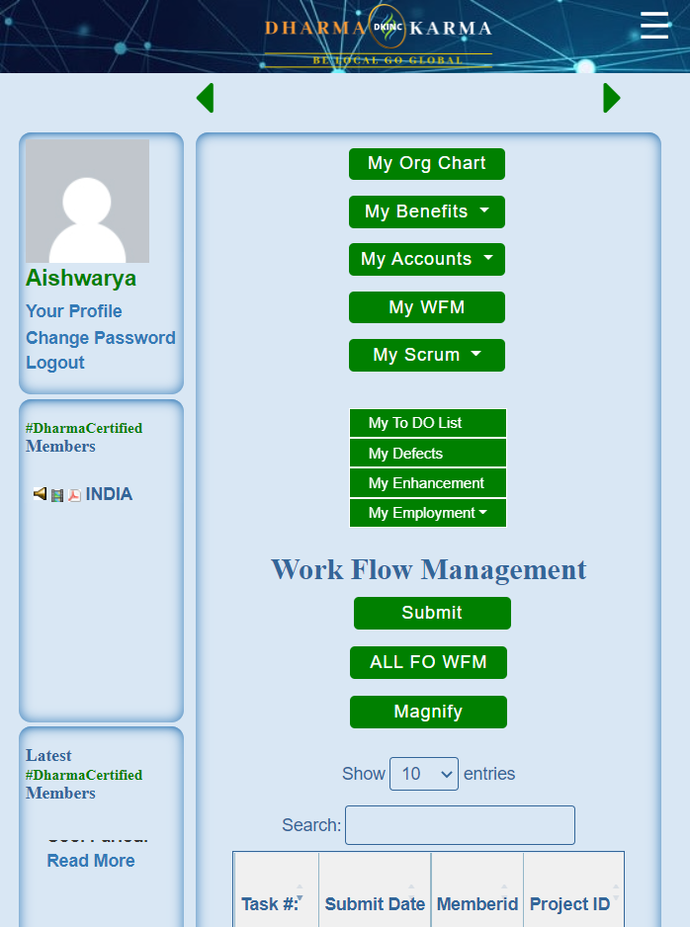  As Expected for smaller devices from - 585px
Test Result | PASS

